Exercise: DOM
Problems for in-class lab for the "JS Advanced" Course @SoftUni". Submit your solutions in the SoftUni judge system at https://judge.softuni.bg/Contests/1802/Exercise-DOM

Subtraction
An HTML page holds two text fields with ids "firstNumber" and "secondNumber". Write a function to subtract the values from these text fields and display the result in the div named "result".

HTML and JavaScript Code
Implement the above to provide the following functionality:
- Your function should take the values of "firstNumber" and "secondNumber", convert them to numbers, subtract the second number from the first one and then append the result to the <div> with id="result".
- Your function should be able to work with any 2 numbers in the inputs, not only the ones given in the example.

Example
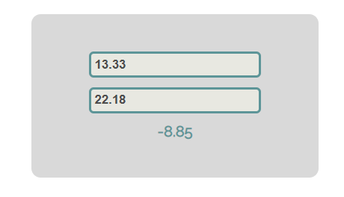

Hints
We see that the textboxes and the div have id attributes on them.
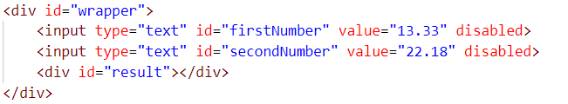
We can take the numbers directly from the input field by using the getElementById() function. After we have taken the elements from the DOM, it’s time to do the actual work. We get the values of the two textboxes, the value of a textbox, as one would expect, is text. In order to get a number, we need to use a function to parse them.
All that’s left now is to append the result to the div. We use the same function to get the result element by id and change its text content to the result of the subtraction.
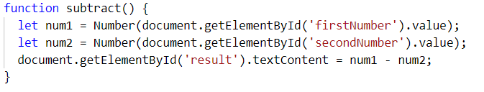
Our code is ready now. Submit only the subtract() function in judge.

Fill Dropdown
Your task is to take values from input fields with ids "newItemText" and "newItemValue". Then you should create and append an <option> to the <select> with id "menu".

Example
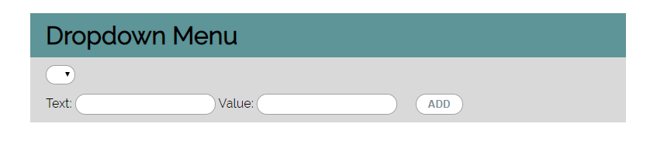

Hints
- Your function should take the values of newItemText and newItemValue. After that you should create a new option element and set its textContent and its value to the newly taken ones.
- Once you have done all of that, you should append the newly created option as a child to the select item with id "menu".
- Finally, you should clear the value of the two input fields.

Accordion
An html file is given and your task is to show more/less information by clicking a [ADD] button (it is not an actual button, but a span that has an onclick event attached to it). When [More] button is clicked, it reveals the content of a hidden div and changes the text of the button to [Less]. When the same link is clicked again (now reading Less), hide the div and change the text of the link to More. Link action should be toggleable (you should be able to click the button infinite amount of times).

Example
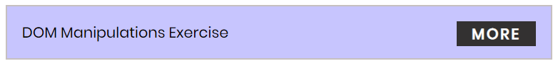
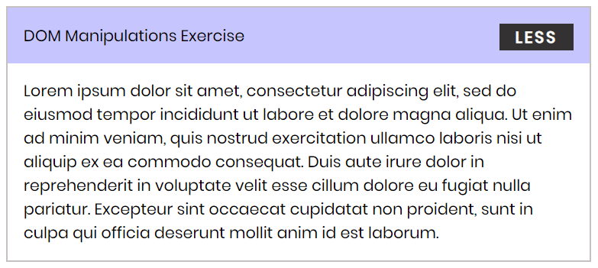

Hints
- To change the text content of a button, you could use getElementsByClassName. However, that returns a collection and we need only one element from it, so the correct way is to use getElementsByClassName("button")[0] as it will return the needed span element.
- After that we should change the display style of the div with an id "extra". If the display style is "none", we should change it to "block" and the opposite.
- Along with all of this, we should change the text content of the button to [Less]/[More].

Order the names
Write a function that orders names alphabetically.
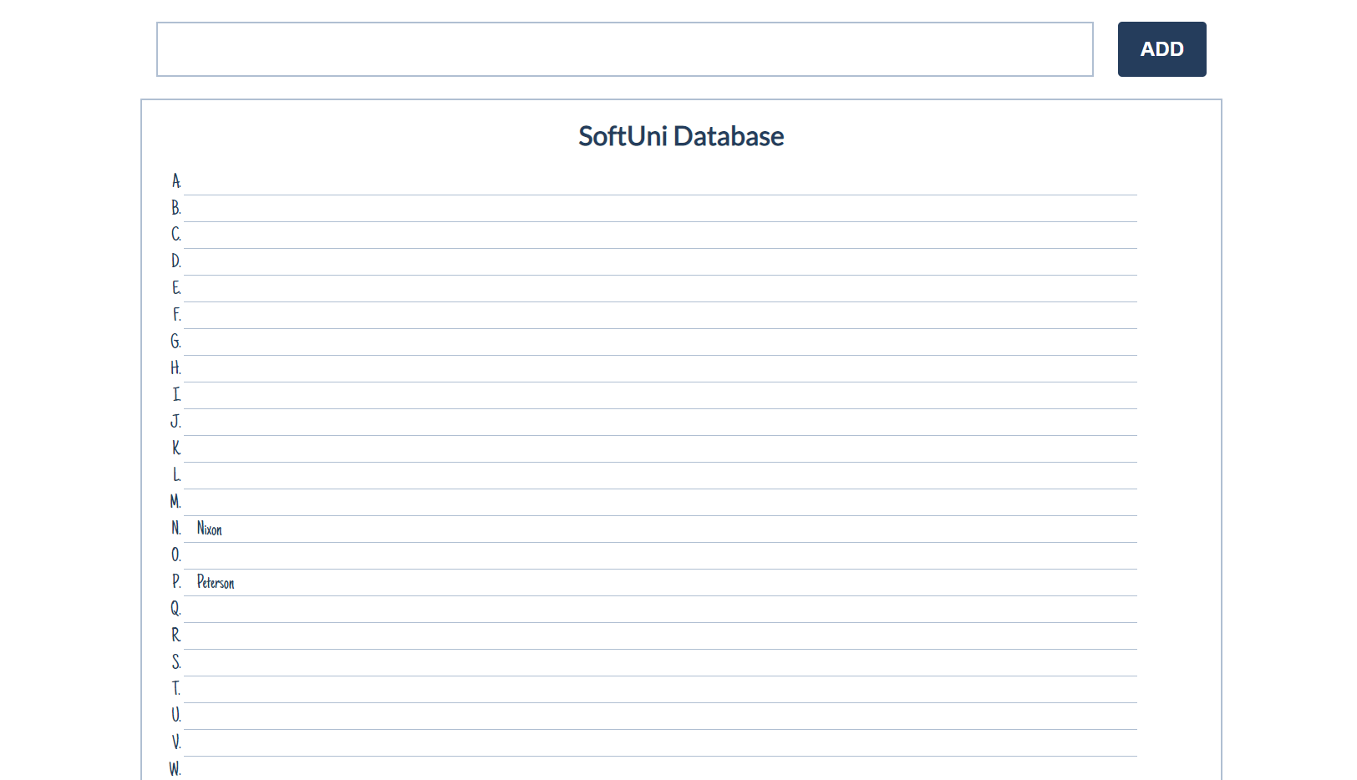
You will receive a name of a student as an input. When the "Register" button is clicked, you should
add the given student name in the SoftUni Database, while keeping the alphabetial order.
For instance, if we register David, his name should appear in the D column.
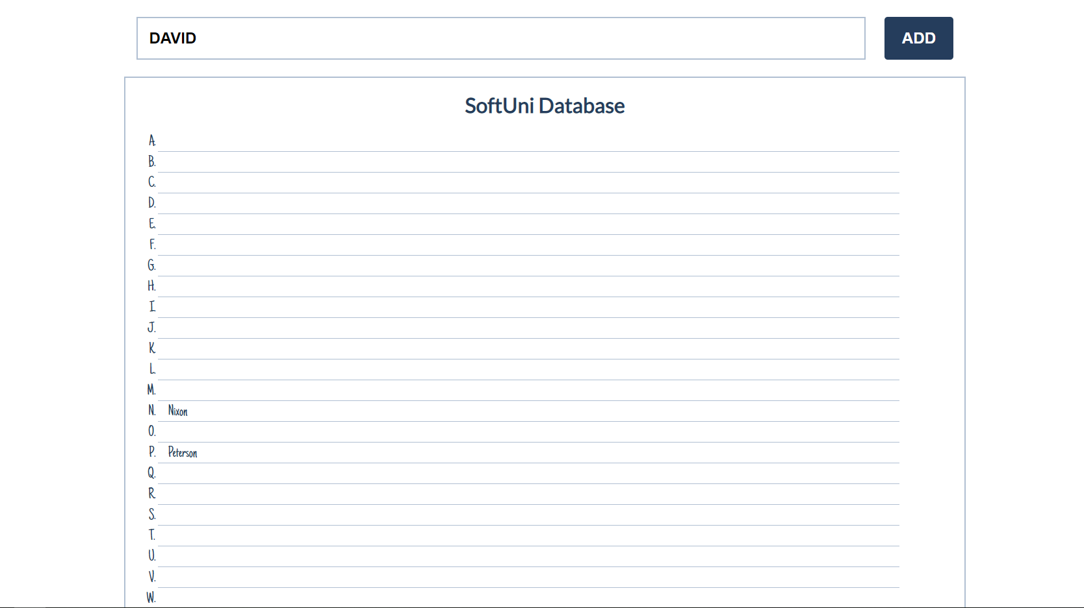

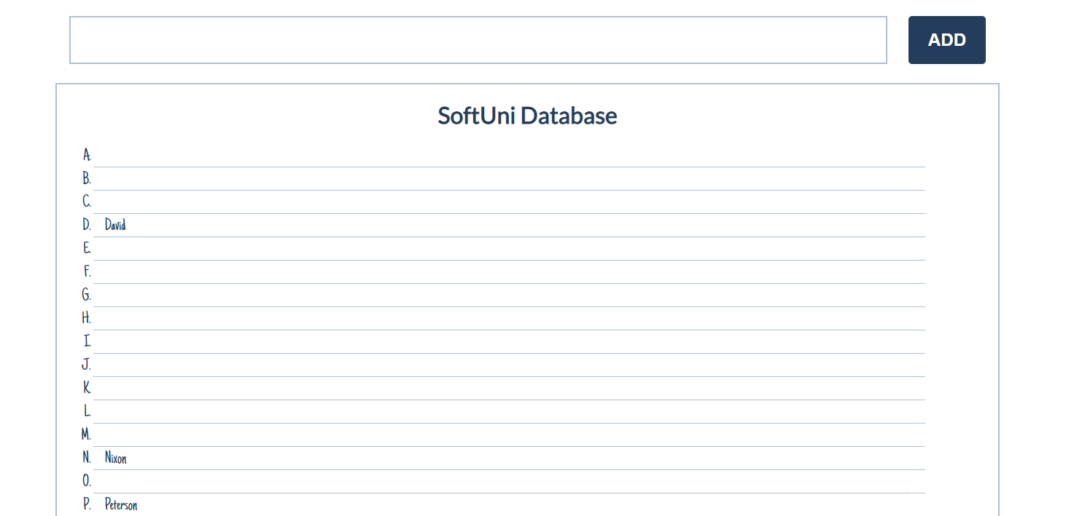
If you receive more than one name with the same starting letter, you should join all names by a
comma and a space (", ").
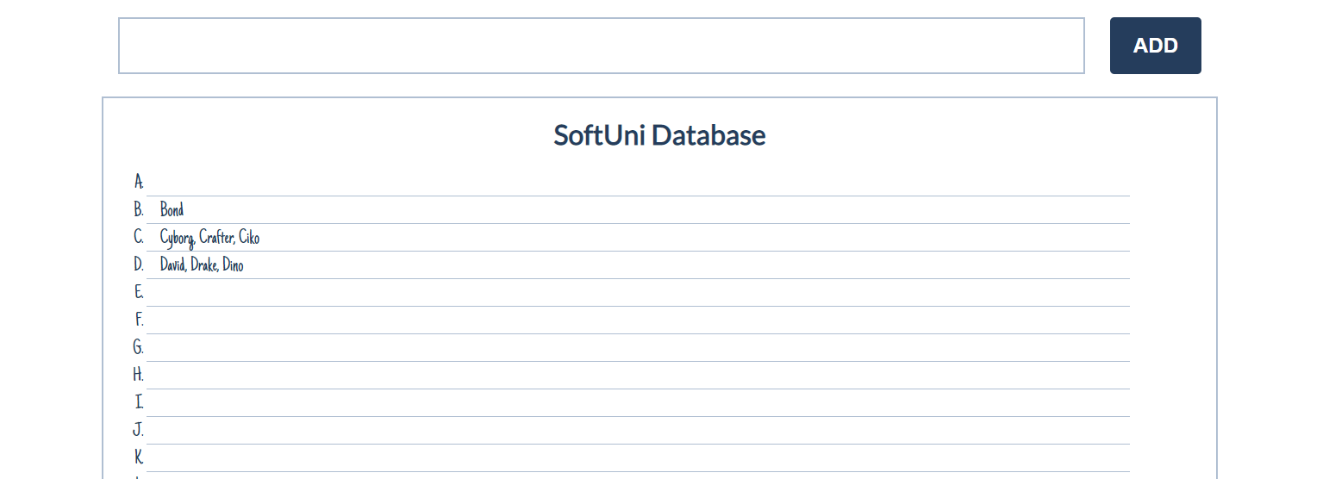

Chat Room
Write a function to create the functionality of a chat room.
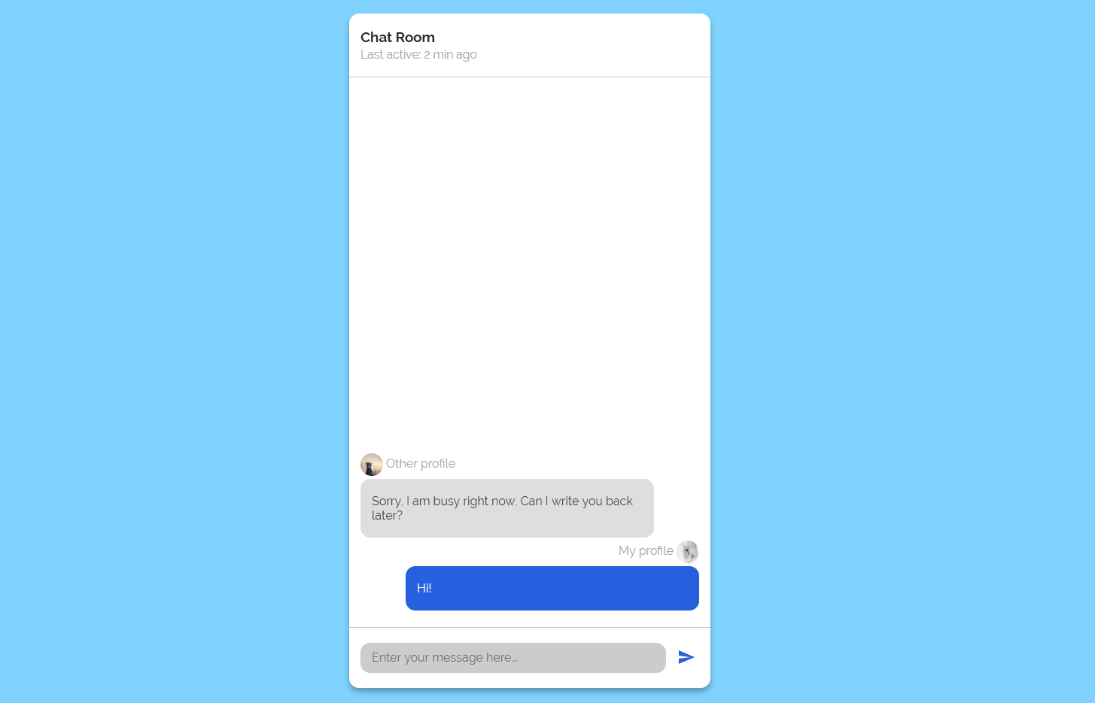
Note: Do not forget to add event listener to the send button!
The new div element with class message my-message should contain the current message that is about to be send.
The current div should be appended to the div with an id="chat_messages".
The input should be cleared on each click of the send button.
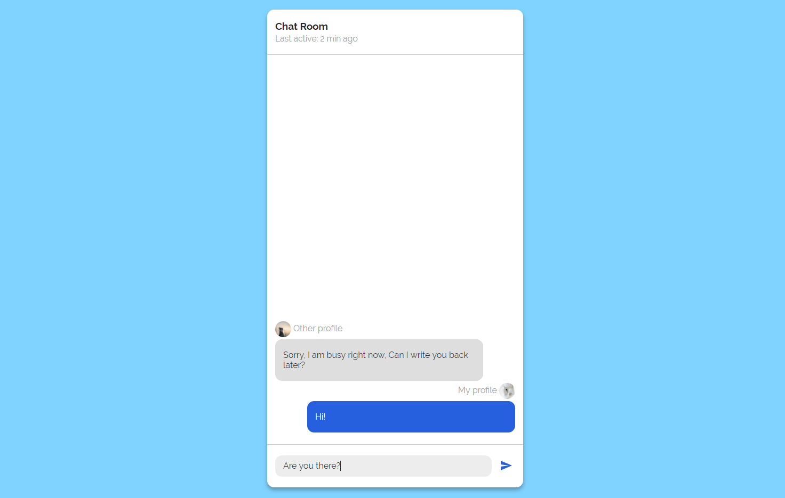
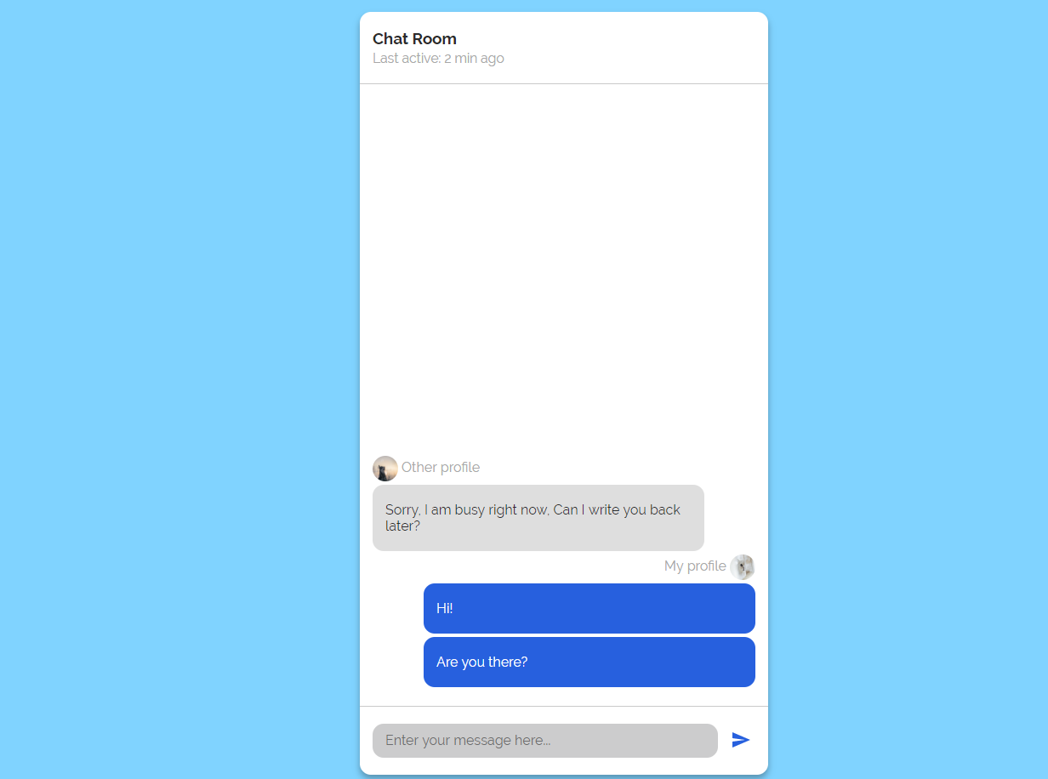

Numpad Calculator
Write a function that implements a calculator that has the following functionalities:
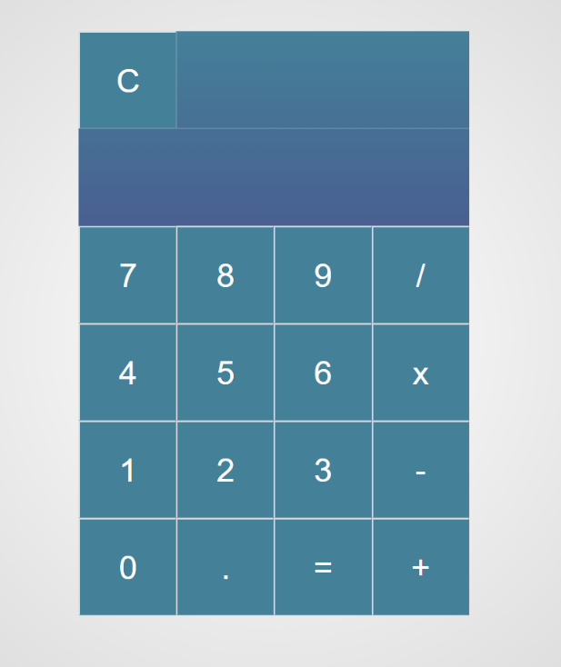
When one of the buttons is clicked, its value should be shown in the "Expression" field (#expressionOutput).
For instance, if we click on the button with value 9, the expected result should be:
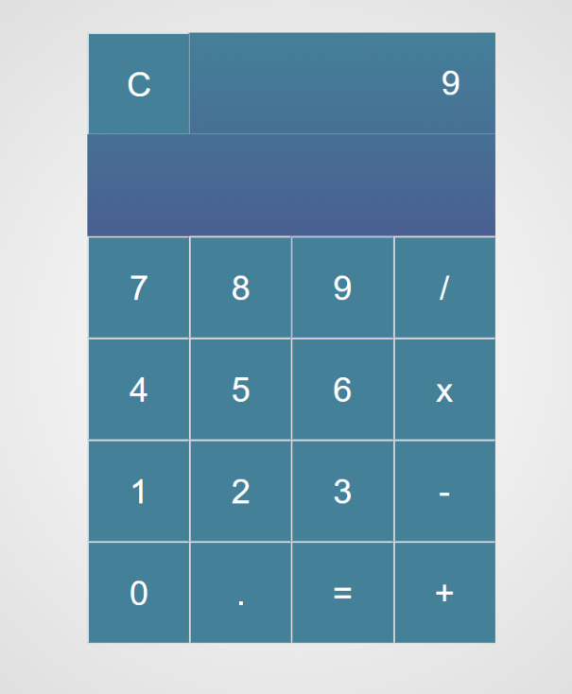
If the current Expression field (#expresisonOutput) contains the whole math expression (left operand, operator and right operand: Example: 9 + 2), the expected result should be:
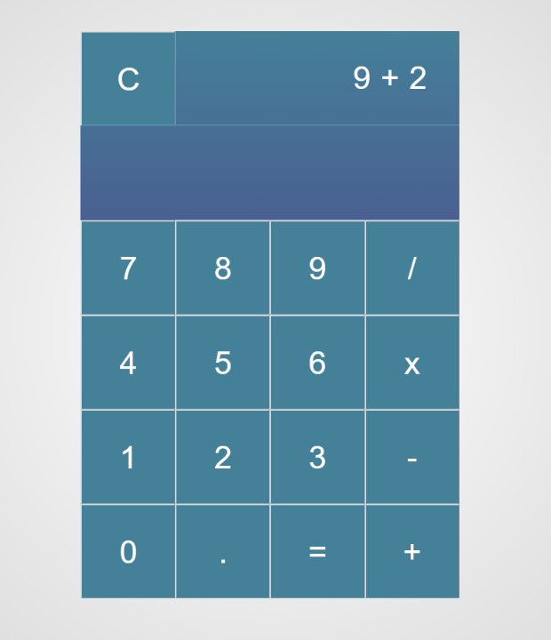
When the equal sign "=" is pressed, the result of that expression should appear in the Result field (#resultOutput)
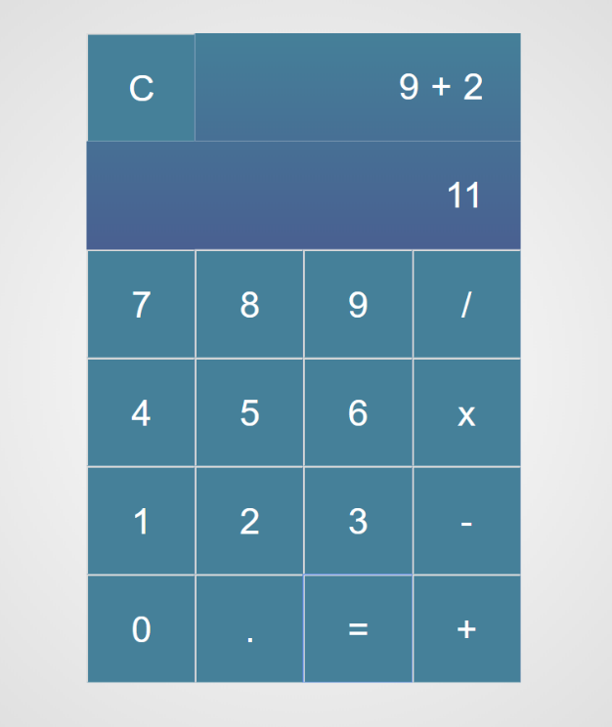
Otherwise, if we create an invalid expression such as "99 +" (without second/right operand) and we hit the equal sign "=", the expected result should be:
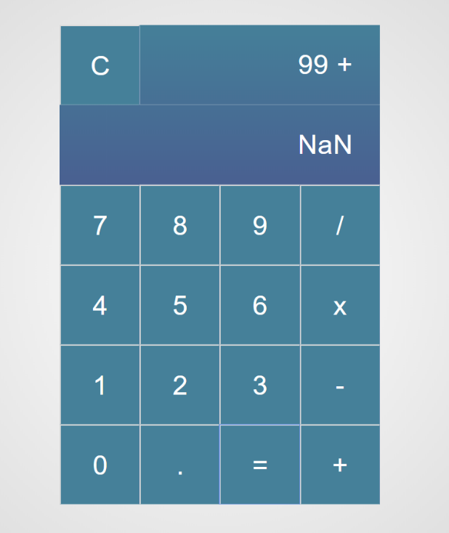

The "Clear" button should clear both Expression and Result fields (#expressionOutput and #resultOutput)
For instance, if we have the following expression:
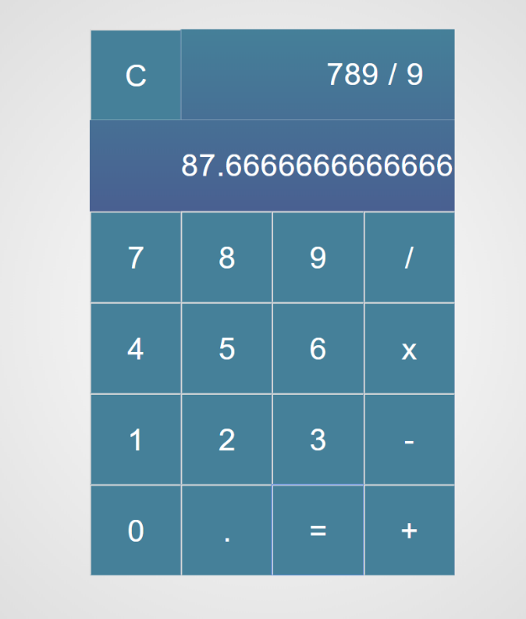
And we press "Clear", the expected result should be:
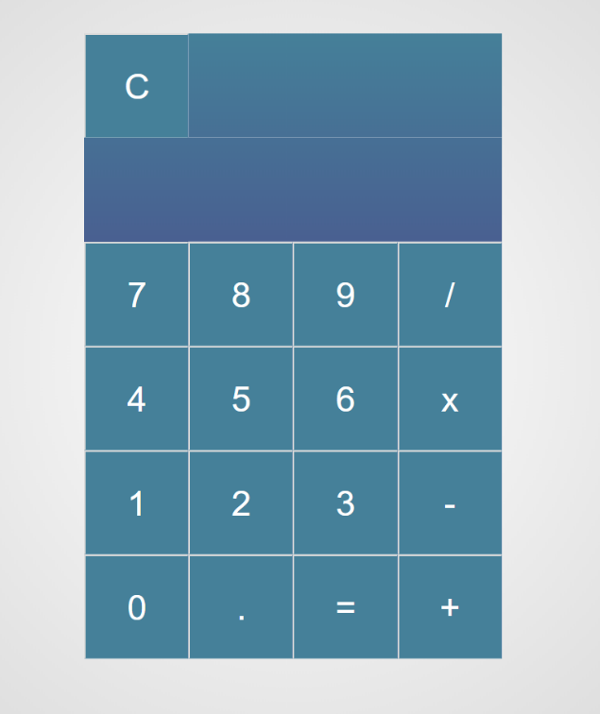

Number Convertor
Write a function that converts a decimal number to binary and hexadecimal.

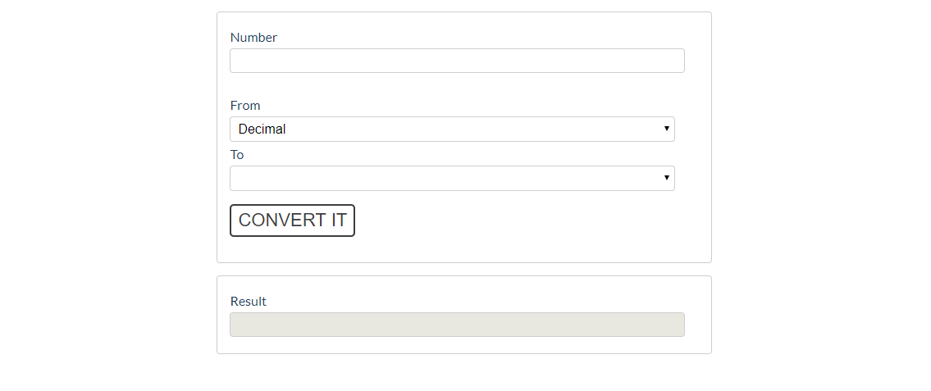
The given number will always be in decimal format. The "From" select menu will only have a
Decimal option, but the "To" select menu will have two options: Binary and Hexadeicmal.
This means that our program should have the functionality to convert decimal to binary and
decimal to hexadecimal.
Note that "To" select menu by default is empty. You have to insert the two options ('Binary' and 'Hexadecimal') inside before continue. Also they should have values ('binary' and 'hexadecimal').
- When the [Convert it] button is clicked, the expected result should appear in the [Result] input field.
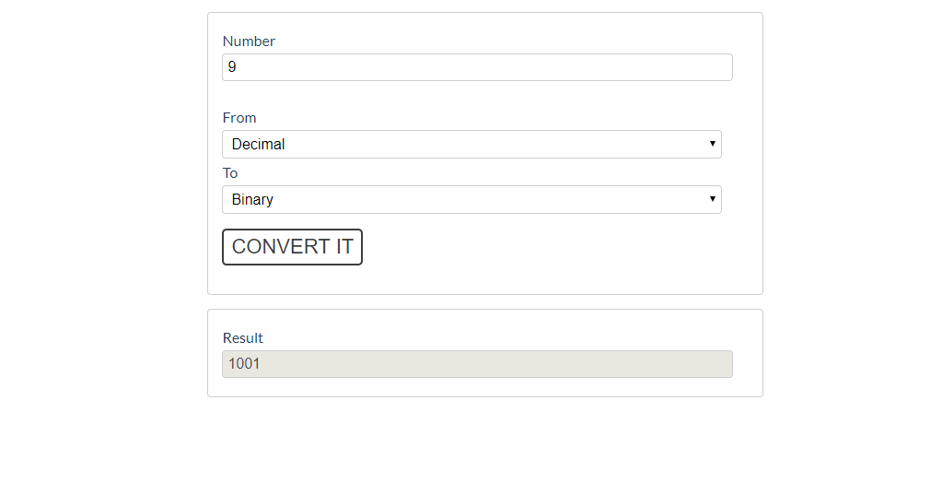
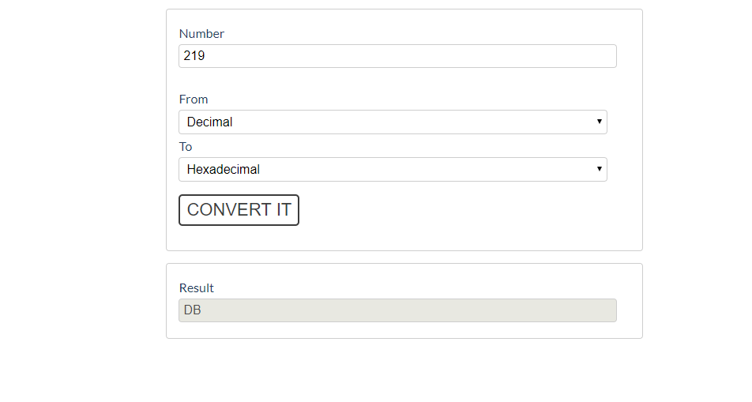

* JavaScript Quizz
Write a function that has the functionality of a quiz.
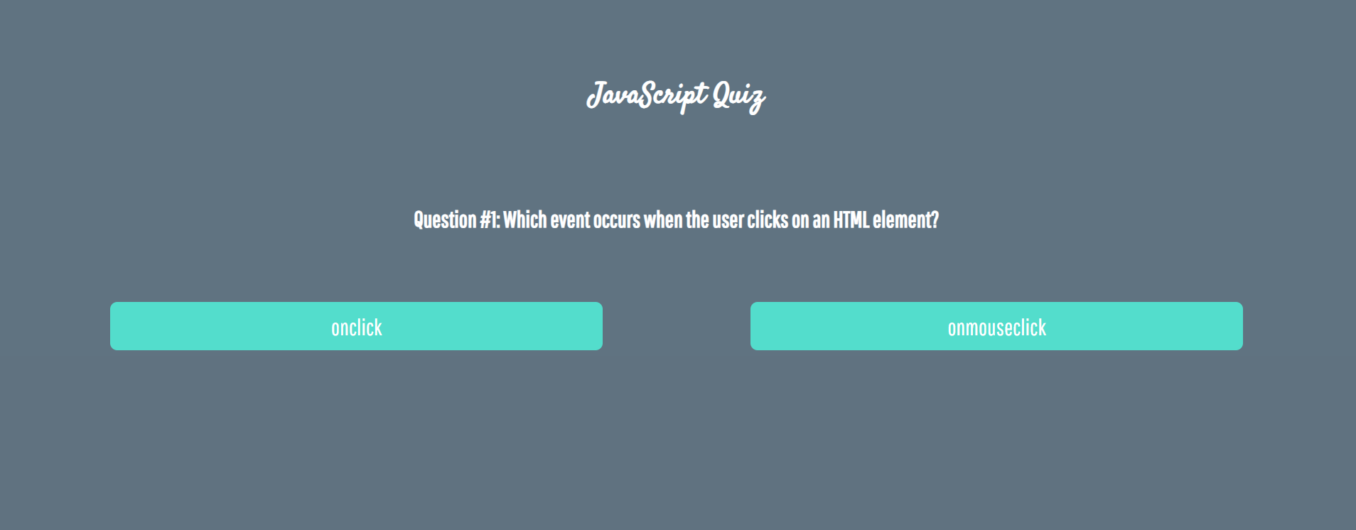
There are three sections that contain one question and 2 possible answers.
The right answer is only one!
When one of the list elements is clicked, the next section must appear (if any…).
After all three questions have been answered, the result div must appear. (Use 'none' and 'block' to hide and show the question sections)
If all questions are answered correctly, you should prin the following message:
"You are recognized as top JavaScript fan!"
Otherwise, just print "You have {rightAnswers} right answers".
The right answers are (onclick, JSON.stringify() and A programming API for HTML and XML documents).
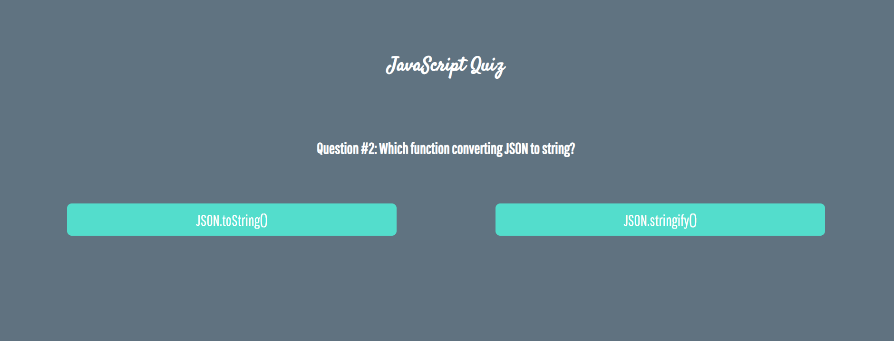
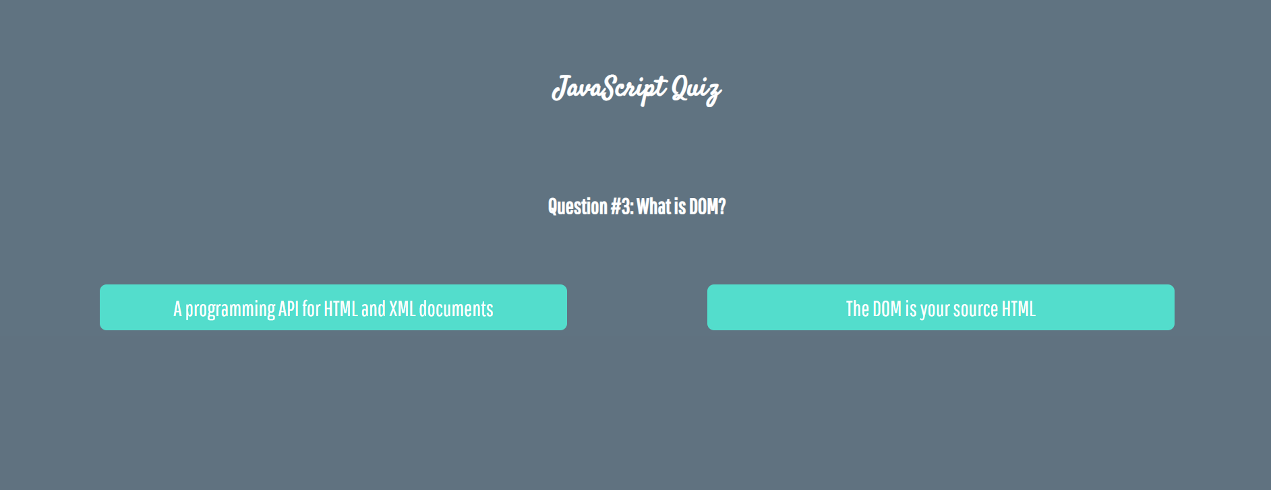



* Shopping Cart
You will be given some products that you should be able to add to your cart. Each product will have a name, picture and a price.
When the "Add" button is clicked, append the current product to the textarea in the following format: "Added {name} for {money} to the cart.\n".
When the button "Checkout" is clicked, calculate the total money that you need to pay for the products that are currently in your cart. Append the result to the textarea in the following format:
"You bought {list} for {totalPrice}."
The list should contain only the unique products, separated by ", ". The total price should be rounded to the second decimal point.
Also, after clicking over "Checkout" and every from above is done you should disable all buttons. (You can't add products or checkout again, if once checkout button is clicked)

Examples
